**DATA ANALYSIS**

1. **Total Tv shows vs Movies**

SELECT

type,

COUNT(*) AS count

FROM netflix

GROUP BY type;

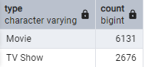

1. **Most Common Movie Rating**

SELECT

rating,

COUNT(*) AS count

FROM netflix

GROUP BY rating

ORDER BY count DESC

LIMIT 5;

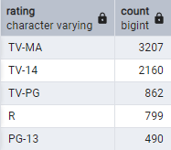

1. **Top 5 countries producing Netflix Content**

SELECT

country,

COUNT(*) AS count

FROM netflix

WHERE country <> 'Unknown'

GROUP BY country

ORDER BY count DESC

LIMIT 5;

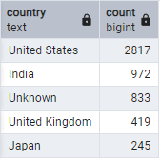

1. **Most Popular Genres**

SELECT

listed_in,

COUNT(*) AS count

FROM netflix

GROUP BY listed_in

ORDER BY count DESC

LIMIT 5;

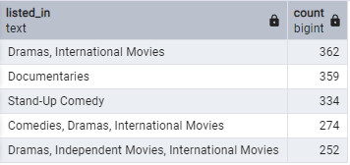

1. **Trend of Movies releases over the year**

SELECT

release_year,

COUNT(*) AS count

FROM netflix

WHERE release_year IS NOT NULL

GROUP BY release_year

ORDER BY release_year DESC;

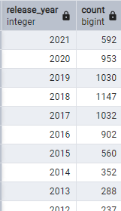

1. **Get the earliest & latest added Shows**

-- **Earliest added show:**

SELECT

title,

date_added

FROM netflix

ORDER BY date_added ASC

LIMIT 1;



-- **Latest added show**

SELECT

title,

date_added

FROM netflix

WHERE date_added IS NOT NULL

ORDER BY date_added DESC

LIMIT 1;



1. **list of all Movies release in 2020**

SELECT

title,

release_year

FROM netflix

WHERE release_year = 2020;



1. **Top 5 most frequent directors**

SELECT

director,

COUNT(*) AS total_movies

FROM netflix

WHERE director IS NOT NULL AND director <> 'Unknown'

GROUP BY director

ORDER BY total_movies DESC

LIMIT 5;

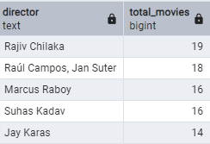

1. **Count of content added each year**

SELECT

EXTRACT(YEAR FROM date_added) AS year_added,

COUNT(*) AS total_count

FROM netflix

WHERE date_added IS NOT NULL

GROUP BY year_added

ORDER BY year_added DESC;

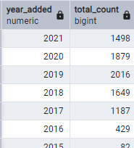

1. **find movies with longest duration**

SELECT

title,

duration

FROM netflix

WHERE duration LIKE '% min'

ORDER BY CAST(SPLIT_PART(duration, ' ', 1) AS INTEGER) DESC

LIMIT 5;



1. **Top 5 Actors with most appearances**

SELECT

unnest(string_to_array(casts, ', ')) AS actor,

COUNT(*) AS appearances

FROM netflix

WHERE casts IS NOT NULL AND casts <> 'Unknown'

GROUP BY actor

ORDER BY appearances DESC

LIMIT 5;

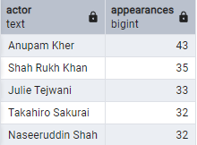

1. **find TV shows with more than 5 seasons**

SELECT

title,

duration

FROM netflix

WHERE duration LIKE '% Season%'

AND CAST(SPLIT_PART(duration, ' ', 1) AS INTEGER) > 5;

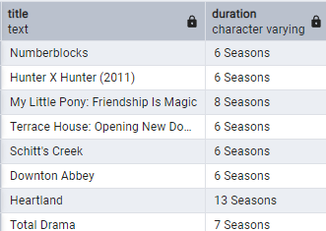

1. **Find Most Common Movie Duration**

SELECT

duration,

COUNT(*) AS count

FROM netflix

WHERE duration LIKE '% min'

GROUP BY duration

ORDER BY count DESC

LIMIT 2;

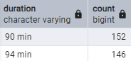

**-- END --**